***PUBLIC TRANPORTATAION ANALYSIS***

***Definition for public transportation analysis:***

Public transport may be defined as any form of passenger or freight transport that is available for hire and reward. In practice, it usually refers to land-based passenger transport and in particular bus and train services and variants thereof. It is this narrower definition that is used in this article.

***Analysis objectives:***

Definition:

The objective of transportation model is to determine the schedule for transportation of goods from source to destination in such a way that minimizes the shipping cost and satisfies all the demand and supply containers.

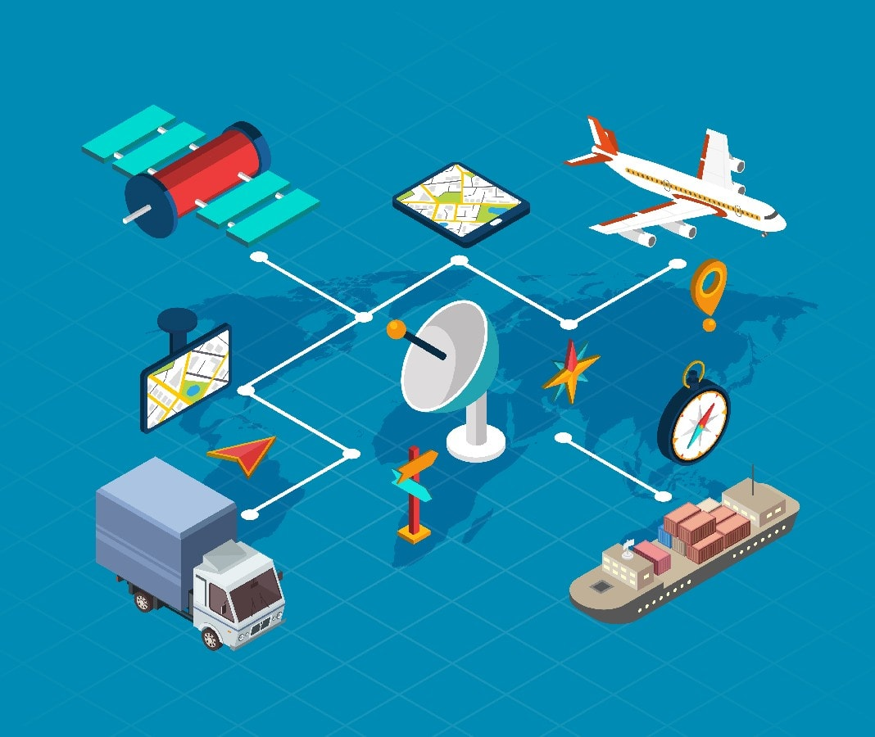

Passenger Satisfaction:

The overall passengers´ satisfaction with public city transport may be affected by the overall service quality. Frequency, punctuality, cleanliness in the vehicle, proximity, speed, fare, accessibility and safety of trans- port, information and other factors can influence passengers´ satisfaction.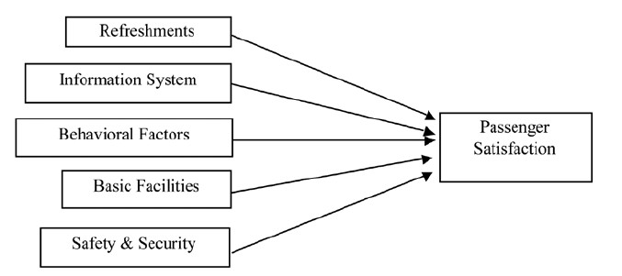

On-time Performance:

On-time performance is defined as a bus arriving, passing, or leaving a predetermined bus stop along its route within a time period that is no more than x minutes earlier and no more than y minutes later than a published schedule time.

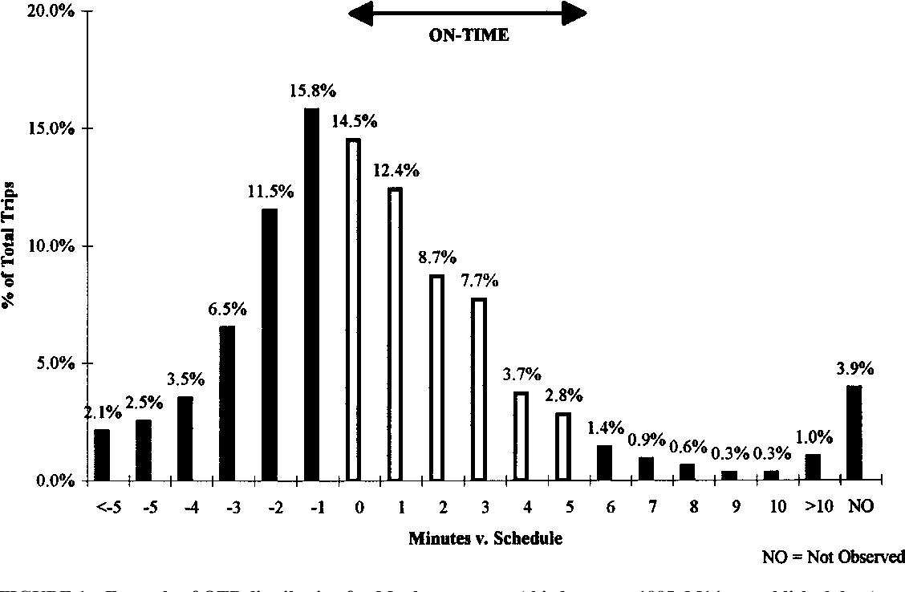

Service efficiency:

The service quality factors with a major effect on passenger satisfaction are service planning and network. The reliability, personnel and information variables have a significant impact on service planning whereas the bus stop availability route characteristics and frequency have a significant impact on network.

the factors affecting transport services;

The transport of people or goods from one place to another depends on many factors: distance, physiography, routes and means, market, climate, products, time, cost and duration.

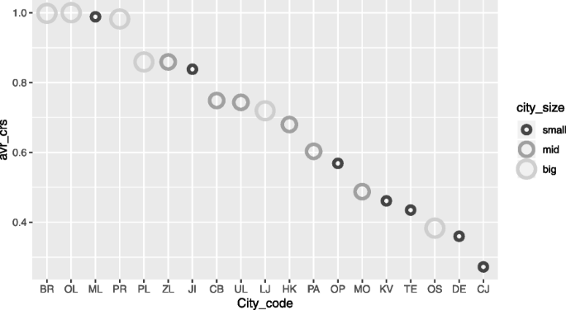

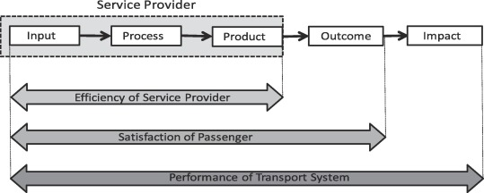

OBJECTIVES ANALYSIS FOR TRANSPORTATION.

***Data collection:***

[Data collection](https://www.techopedia.com/definition/30318/data-collection) is a systematic method of collecting and measuring data gathered from different sources of information in order to provide answers to relevant questions. An accurate evaluation of collected data can help researchers predict future phenomenon and trends.

Data collection can be classified into two, namely: primary and secondary data. Primary data are raw data i.e. fresh and are collected for the first time. Secondary data, on the other hand, are data that were previously collected and tested.

Source of collection:

Traffic data is essential for transportation engineering projects, as it provides insights into the current and future travel patterns, demands, and behaviors of road users. However, collecting, processing, and analyzing traffic data can be challenging, as there are many sources, methods, and tools available. In this article, you will learn about some of the best sources of traffic data for transportation engineering projects, and how they can help you design, evaluate, and optimize transportation systems.

sources of transportation data

Transportation data can be gathered from a variety of sources, but three of the most common sources are Transportation Management Systems (TMS), carriers or 3rd Party Logistics (3PL) providers, and invoice data.

# Methods of data collection:

The system of data collection is based on the type of study being conducted. Depending on the researcher’s research plan and design, there are several ways data can be collected.

The most commonly used methods are: published literature sources, surveys (email and mail), interviews (telephone, face-to-face or focus group), observations, documents and records, and experiments.

# 1. Literature sources:

This involves the collection of data from already published text available in the public domain. Literature sources can include: textbooks, government or private companies’ reports, newspapers, magazines, online published papers and articles.

This method of data collection is referred to as secondary data collection. In comparison to primary data collection, tt is inexpensive and not time consuming.

# 2. Surveys:

[Survey](https://www.qualtrics.com/experience-management/research/survey-basics/) is another method of gathering information for research purposes. Information are gathered through questionnaire, mostly based on individual or group experiences regarding a particular phenomenon.

There are several ways by which this information can be collected. Most notable ways are: web-based questionnaire and paper-based questionnaire (printed form). The results of this method of data collection are generally easy to analysis.

# 3. Interviews:

[Interview](https://research-methodology.net/research-methods/qualitative-research/interviews/) is a qualitative method of data collection whose results are based on intensive engagement with respondents about a particular study. Usually, interviews are used in order to collect in-depth responses from the professionals being interviewed.

Interview can be structured (formal), semi-structured or unstructured (informal). In essence, an interview method of data collection can be conducted through face-to-face meeting with the interviewee(s) or through telephone.

# 4. Observations:

Observation method of information gathering is used by monitoring participants in a specific situation or environment at a given time and day. Basically, researchers observe the behaviour of the surrounding environments or people that are being studied. This type of study can be [controlled, natural or participant.](https://www.simplypsychology.org/observation.html)

Controlled observation is when the researcher uses a standardised procedure of observing participants or the environment. Natural observation is when participants are being observed in their natural conditions. Participant observation is where the researcher becomes part of the group being studied.

# 5. Documents and records:

This is the process of examining existing documents and records of an organization for tracking changes over a period of time. Records can be tracked by examining call logs, email logs, databases, minutes of meetings, staff reports, information logs, etc.

For instance, an organization may want to understand why there are lots of negative reviews and complains from customer about its products or services. In this case, the organization will look into records of their products or services and recorded interaction of employees with customers.

Real-time data:

Real-time data refers to the traffic data that is collected and transmitted in near real-time, usually by sensors, cameras, or mobile devices. Real-time data can help you monitor and manage the current traffic conditions, such as congestion, incidents, or events. Real-time data can also help you provide traveler information, such as travel time, route guidance, or parking availability. Real-time data can also help you implement adaptive control strategies, such as signal timing, ramp metering, or variable speed limits.

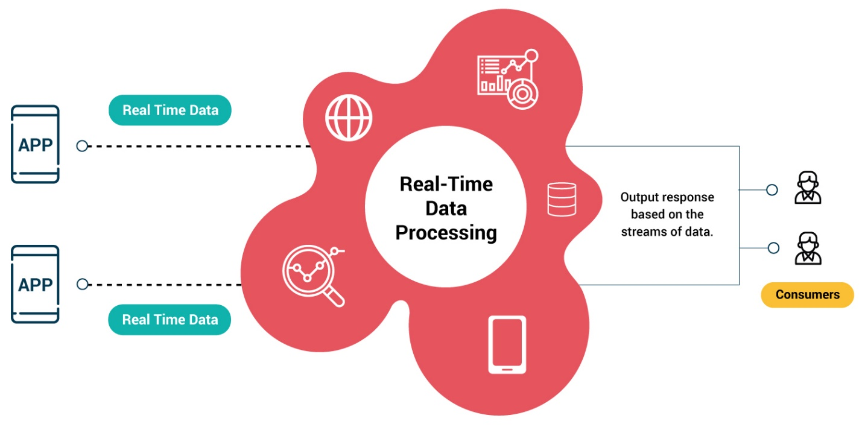

Passenger feedback:

Gathering passenger feedback is key to improving satisfaction levels. By gauging the sentiment of someone travelling on a particular vehicle, an operator can gain accurate and timely data. Using this, issues can be resolved before they escalate, allowing operators to improve the services that they offer.

Our passenger feedback and sentiment analysis solution, Vision, allows transport operators to access measurable and actionable feedback that they receive from their passengers. Using this information, issues can be resolved before they escalate, and products and services can be improved.

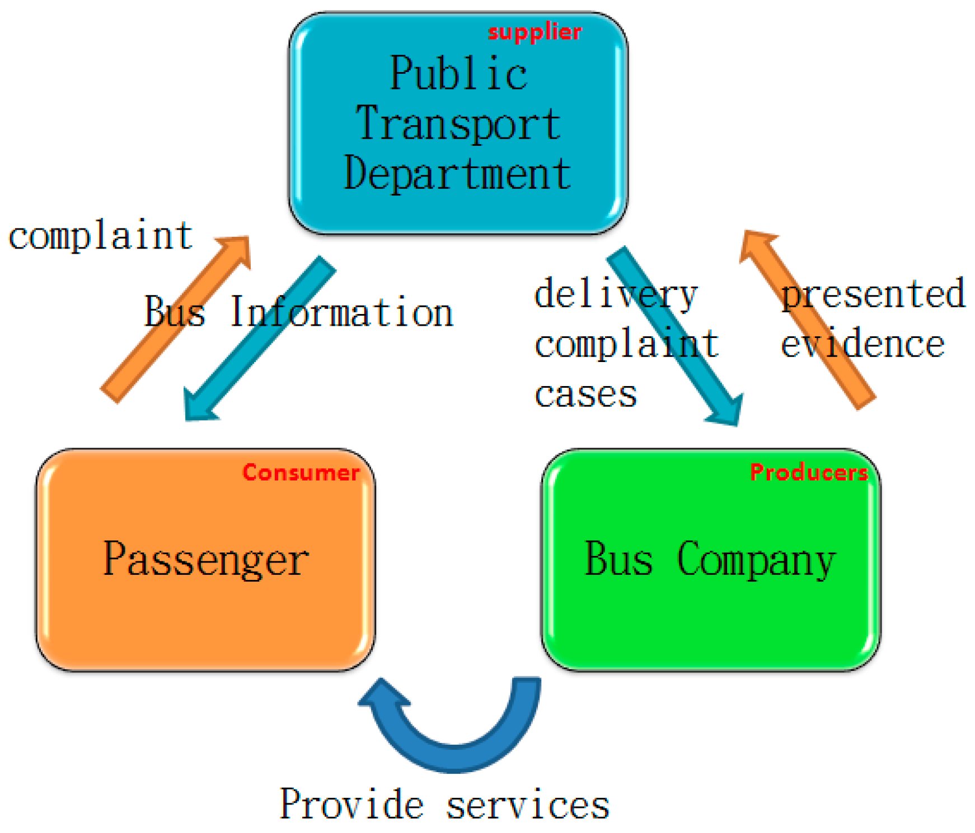

***Visualization Strategy:***

IBM® Cognos ® Analytics provides dashboards and stories to communicate your insights and analysis. You can assemble a view that contains visualizations such as a graph, chart, plot, table, map, or any other visual representation of data.

Creating a dashboard or story:

If you're new to dashboards and stories, review the following steps to understand the general workflow to create a view.

1. Tap plus, and tap Dashboard, or tap Story.

2. Select a template. Cognos Analytics provides templates that contain predefined layouts and grid lines

for easy arrangement and alignment of the visualizations in a view.

3. Add visualizations to your view in one or more of the following ways:

• If you know the type of visualization you want to use, select the visualization type and then add

columns to it.

• If you know the data that you want to see, but are not sure about how to present it, tap and add

a source to the Selected sources panel. Then, drag columns onto the canvas. Cognos Analytics

displays them in the appropriate visualization.

• Tap search, and type a question or a statement. Cognos Analytics creates an appropriate visualization

by analyzing the data in the data set to answer the question or intent of the statement.

• Drag your collected visualizations from the My pins panel to quickly build a story.

4. Limit the data that is displayed by filtering in one or more of the following ways:

• You can filter individual visualizations or on all visualizations in the view.

• You can even filter on a column that is not displayed in the visualization by using a context filter N

• You can select a special value or a range of values.

5. Enhance your view and draw attention to visualizations by adding media, web pages, images, shapes, and text.

6. Personalize your view by changing the theme. You can choose from default, light, or dark themes. You can also customize specific visualization properties such as fill and border color, and opacity.

7. Create more meaningful or complex visualizations by adding columns to an existing visualization. Drag another column onto a visualization and it changes to match the new data added.

8. You can undo and redo your last actions in succession. The ability to undo and redo previous actions is available until you close the view.

9. Test the view.

***Integration code:***

Integration Code means the current section of code made available to a Publisher by The Company on the Site for the purpose of integrating into the Publisher's Website to allow The Company to analyze the impact of Ad Block on that website and provide the Services (as may be amended by The Company from time to time).

Data cleaning:

Data cleaning is the process of fixing or removing incorrect, corrupted, incorrectly formatted, duplicate, or incomplete data within a dataset. When combining multiple data sources, there are many opportunities for data to be duplicated or mislabeled. If data is incorrect, outcomes and algorithms are unreliable, even though they may look correct. There is no one absolute way to prescribe the exact steps in the data cleaning process because the processes will vary from dataset to dataset. But it is crucial to establish a template for your data cleaning process so you know you are doing it the right way every time.

Benefit for data cleaning:

* Removal of errors when multiple sources of data are at play.
* Fewer errors make for happier clients and less-frustrated employees.
* Ability to map the different functions and what your data is intended to do.
* Monitoring errors and better reporting to see where errors are coming from, making it easier to fix incorrect or corrupt data for future applications.
* Using tools for data cleaning will make for more efficient business practices and quicker decision-making.

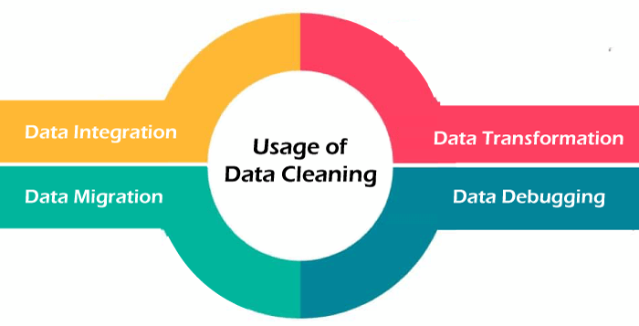

Transformation:

Digital transformation is reshaping the transportation and logistics industry in profound ways. IOT, AI, block chain, autonomous vehicles, and sustainability initiatives are just a few of the key trends that are driving innovation and efficiency in this sector.

Main Areas of the Digital Transformation Process;

* Process Transformation. Business process transformation is a strategic initiative aimed at improving the efficiency and effectiveness of a company's operations. ...
* Business Model Transformation. ...
* Domain Transformation. ...
* Cultural/Organizational Digital Transformation.

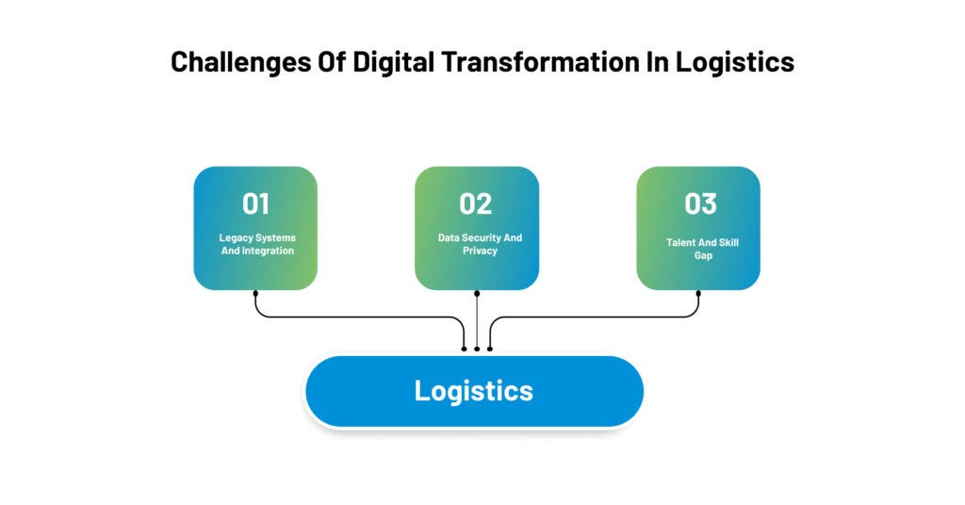

Statistical analysis:

Statistical Techniques for Transportation Engineering is written with a systematic approach in mind and covers a full range of data analysis topics, from the introductory level (basic probability, measures of dispersion, random variable, discrete and continuous distributions) through more generally used techniques (common statistical distributions, hypothesis testing), to advanced analysis and statistical modeling techniques (regression, and time series).

Types of statistical analysis;

Important types are descriptive analysis, inferential analysis, predictive analysis, prescriptive analysis, exploratory data analysis (EDA), and causal analysis. The five basic methods are mean, standard deviation, regression, hypothesis testing, and sample size determination.

